**Investigating the Effect of Different Autonomy Levels on User Acceptance and User Experience in Self-Driving Cars with a ­VR Driving Simulato**

**Supti Mithila Jannat**

Dept of CSE Dept of CSE

Daffodil International University Daffodil International University

Dhaka, Bangladesh Dhaka, Bangladesh

**Abstract**—In this paper, we report on an architecture for a selfdriving car that is based on a VR driving cars. Self-driving cars have to take decisions based on their sensory input in real-time, providing high reliability with a strong demand in functional safety. Vehicles are not ready to be fully connected as various attacks are currently possible against their control systems. In this paper, we analyse possible attack scenarios on a recently released all-electric car and investigate their impact on real life driving scenarios. We challenge the current state-of-the-art technology in today’s vehicles and provide a vulnerability analysis on modern embedded systems. In the modern era, the vehicles are focused to be automated to give human driver relaxed driving. In the ﬁeld of automobile various aspects have been considered which makes a vehicle automated. In this paper we report on an architecture for a selfdriving car that is based on ROS2. Self-driving cars have to take decisions based on their sensory input in real-time, providing high reliability with a strong demand in functional safety. In principle, self-driving cars are robots. However, typical robot software, in general, and the previous version of the Robot Operating System (ROS), in particular, does not always meet these requirements. First experiments with anautomated real passenger car at lower and higher speed-levels show that our approach seems feasible for autonomous driving under the necessary real-time conditions.

**Keywords**—Self-driving car, autonomous driving, architecture, robot operating system,

1. **INTRODUCTION**

Since the first automobile, many vehicle functions have been automated, such as starting the engine, shifting transmission gears, and opening doors and windows, but the actual driving task, fundamentally, has changed very little. Automating the driving task represents a huge safety potential, but it also presents many challenges[10]. Computers don't drive while impaired by alcohol and can process larger amounts of information to make quicker decisions compared with humans. On the other hand, development of these technologies takes a long time since the driving environment is complex, and the human and economic costs of errors are high[11]. We have focused on two applications of an Automated Vehicles here and designed a prototype vehicle for that. The one major issue is during heavy traffic a driver has to continuously push brake, accelerator and clutch to move to destination slowly[16]. We have proposed a solution to relax the driver in that situation by making vehicle smart enough to make decisions automatically and move by maintaining a specified distance from vehicles and obstacles around[17]. Nine months ago, a new effort was started at NVIDIA that sought to build on DAVE and create a robust system for driving on public roads[20]. The primary motivation for this work is to avoid the need to recognize specific human-designated features, such as lane markings, guard rails, or other cars, and to avoid having to create a collection of “if, then, else” rules, based on observation of these features. This paper describes preliminary results of this new effort[21].

**LITERATURE REVIEW**

The ﬁrst research into self-driving cars were undertaken in the late 1980s already with the PROMETHEUS project .Within this project it was shown that it’s possible to drive a motorway controlled by a computer program, though still under restricted lighting and weather conditions. Like today, the prevalent sensors were camera systems. In the late 2000s the topic became a hot research topic again with the DARPA Grand and Urban Challenges[30].In 2009 the Tartan R acing team won the Urban Challenge showing that it is possible to drive autonomously in an urban environment. The DARPA challenges also been led to the Google X project, which gave the whole ﬁeld quite a push. In , a brief overview of the self-driving car activities on the different continents is given[29]. Given the complexity of the automotive electronic architecture, works such as and provide a taxonomy of the different attacks such as systematic manipulation and intrusion[27]. A block diagram of our training system is shown in Figure 1. Images are fed into a CNN which then computes a proposed steering command[20]. The proposed command is compared to the desired command for that image and the weights of the CNN are adjusted to bring the CNN output closer to the desired output. The weight adjustment is accomplished using back propagation as implemented in the

Torch 7 machine learning package[21]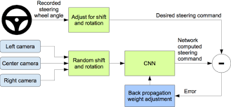

Figure 1: Training the neural network.

Once trained, the network can generate steering from the video images of a single center camera. This configuration is shown in Figure 2[20].

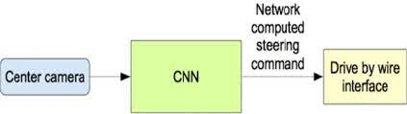

Figure 2: The trained network is used to generate steering commands from a single front-facing center camera.

**Simulation**

Before road-testing a trained CNN, we first evaluate the networks performance in simulation. A simplified block diagram of the simulation system is shown in Figure 5. The simulator takes pre-recorded videos from a forward-facing on-board camera on a human-driven data-collection vehicle and generates images that approximate what would appear if the CNN were, instead, steering the vehicle. These test videos are time-synchronized with recorded steering commands generated by the human driver[7]. 5 Since human drivers might not be driving in the center of the lane all the time, we manually calibrate the lane center associated with each frame in the video used by the simulator. We call this position the “ground truth”. The simulator transforms the original images to account for departures from the ground truth. Note that this transformation also includes any discrepancy between the human driven path and the ground truth[8]. The transformation is accomplished by the same methods described in Section 2. The simulator accesses the recorded test video along with the synchronized steering commands that occurred when the video was captured[21]. The simulator sends the first frame of the chosen test video, adjusted for any departures from the ground truth, to the input of the trained CNN. The CNN then returns a steering command for that frame. The CNN steering commands as well as the recorded human-driver commands are fed into the dynamic model [8] of the vehicle to update the position and orientation of the simulated vehicle. The simulator then modifies the next frame in the test video so that the image appears as if the vehicle were at the position that resulted by following steering commands from the CNN[26]. This new image is then fed to the CNN and the process repeats. The simulator records the off-center distance (distance from the car to the lane center), the yaw, and the distance traveled by the virtual car. When the off-center distance exceeds one meter, a virtual human intervention is triggered, and the virtual vehicle position and orientation is reset to match the ground truth of the corresponding frame of the original test video.

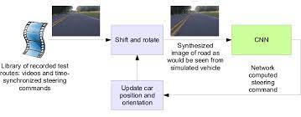

Figure 3: Block-diagram of the drive simulator.

**Simulation Tests**

We estimate what percentage of the time the network could drive the car (autonomy). The metric is determined by counting simulated human interventions (see Section 6). These interventions occur when the simulated vehicle departs from the center line by more than one meter. We assume that in real life an actual intervention would require a total of six seconds: this is the time required for a human to retake control of the vehicle, re-center it, and then restart the self-steering mode[13]. We calculate the percentage autonomy by counting the number of interventions, multiplying by 6 seconds, dividing by the elapsed time of the simulated test, and then subtracting the result from 1:

autonomy = (1 − (number of interventions) · 6 seconds elapsed time [seconds] ) · 100

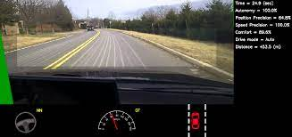

Figure 4: Screen shot of the simulator in interactive mode. See Section 7.1 for explanation of the performance metrics. The green area on the left is unknown because of the viewpoint transformation. The highlighted wide rectangle below the horizon is the area which is sent to the CNN[22].

Thus, if we had 10 interventions in 600 seconds, we would have an autonomy value of (1 − 10 · 6 600 ) · 100 = 90%

**Gist of Research**



Self-driving vehicles are cars or trucks in which human drivers are never required to take control to safely operate the vehicle. Also known as autonomous or “driverless” cars, they combine sensors and softwarecontrol, navigate, and drive the vehicle[17] Currently, there are no legally operating, fully-autonomous vehicles in the United States. There are, however, partially-autonomous vehicles—cars and trucks with varying amounts of self-automation, from conventional cars with brake and lane assistance to highly-independent, self-driving prototypes[15].

Though still in its infancy, self-driving technology is becoming increasingly common and could radically transform our transportation system (and by extension, our economy and society). Based on automaker and technology company estimates, level 4 self-driving cars could be for sale in the next several years (see the callout box for details on autonomy levels)[18].

**Data Collection**

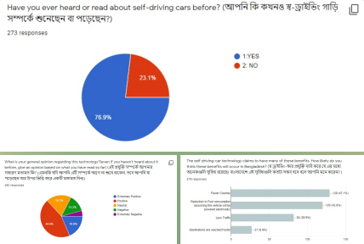

In this data collection, we see,76.9% read about self driving cars and 23.1% they donot read about self driving car.so, most of the people know self auto driving cars before. And also general opinion regarding this technology positive ans is 44.6% and negative ans 13.2%. besides another question ans extemly positive 19.6% and neutral ans is 18.2%.the self driving cars fewer claims crashes 47.2% and reduction in fewer comsumptiom 43.8%. destination are reached faster 9.9%. that why, many cars crashes ,fewer consumption and less then reached faster.

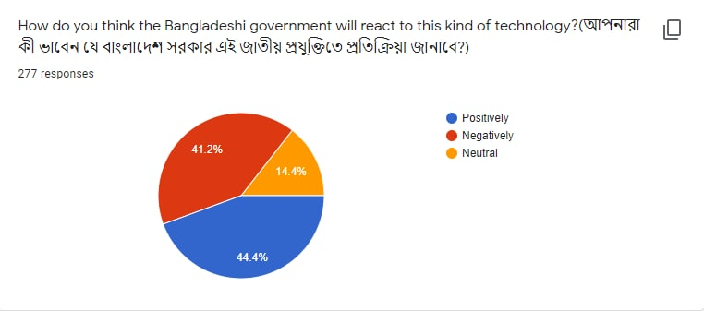

The government will react to the kind of technology if positively 44.4% and negatively 4.1% and others 54.4%. that why we know other country opinion The UK government on Wednesday became the first country to announce it will regulate the use of self-driving vehicles at slow speeds on motorways, with the first such cars possibly appearing on public roads as soon as this year.

Britain's transport ministry said it was working on specific wording to update the country's highway code for the safe use of self-driving vehicle systems, starting with Automated Lane Keeping Systems (ALKS) - which use sensors and software to keep cars within a lane, allowing them to accelerate and brake without driver input.[8]The government said the use of ALKS would be restricted to motorways, at speeds under 37 miles (60 km) per hour.

The UK government wants to be at the forefront of rolling out autonomous driving technology and the transport ministry forecasts by 2035 around 40% of new UK cars could have self-driving capabilities, creating up to 38,000 new skilled jobs[9].



Many people donot able trust owning a driver less car its positive maximum ans and negative minimum ans. Besides yourself owning less driving car positively 55.7% and negatively 44.3 %.

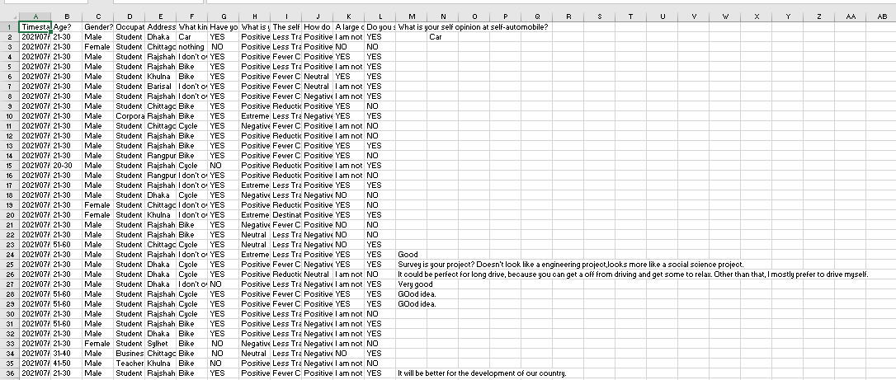

**Table 1 : data sheet**

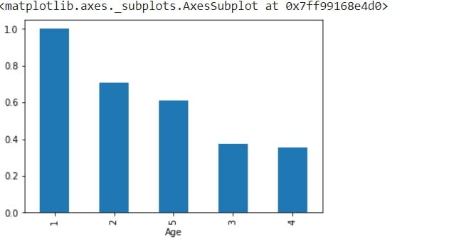

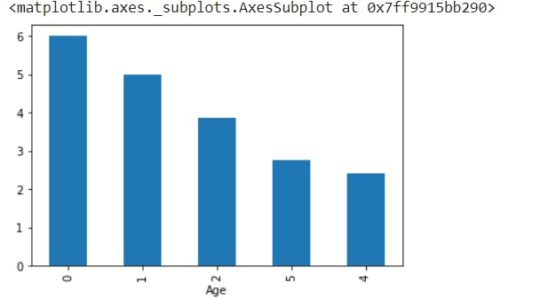

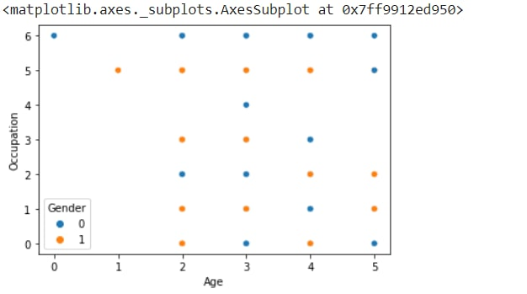

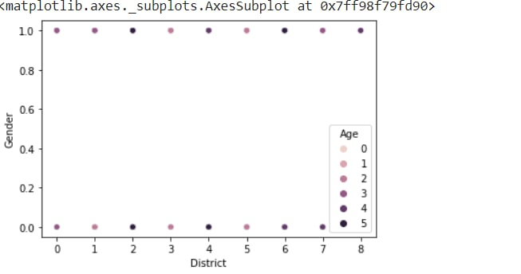

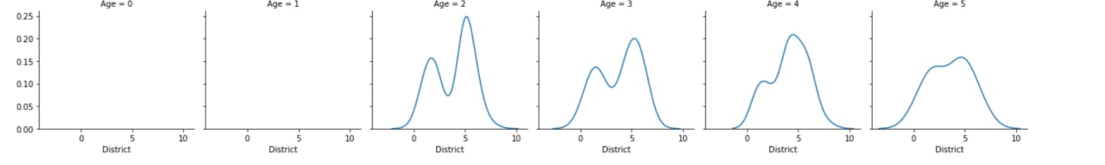

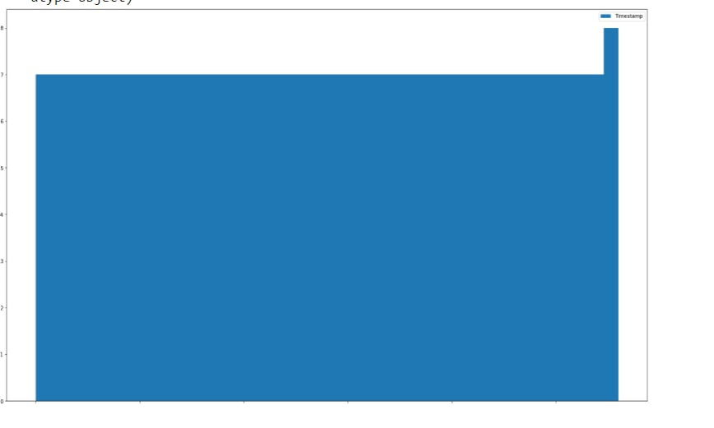

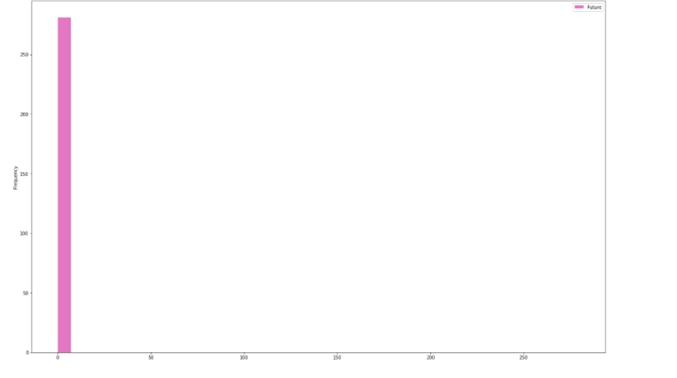

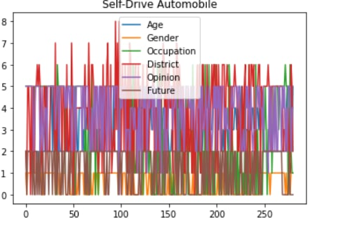

Here I our coding part graph. In this graph we work different classifier linear regression, logistic regression,KNN, Naïve bayers and test method and its running code different graph collections.

Im doing a literature review and i want to put the relevant literature in an excel table to check it later. Whenever i am exporting something in CSV (using excel) it puts all Categories (e.g. Author, date, title...) in one column. But at the same time the keywords will get put in different columns (each keyword in one column). So i am asking myself: is it possible that by exporting it excel puts every category in one column, seperated from the others[13]. And for keywords that it exports all keywords into one column. Maybe I can change a setting in excel? I have found nothing on google yet and i hope someone maybe has had a similiar problem[14].

**Methodology**

Due to the advent of active safety features and

automated driving capabilities, the scope and complexity of embedded computing systems within automobiles continue to increase[11]Moreover, with the introduction of communica-tion technologies like dedicated short range communications(DSRC), autonomous vehicles can also communicate with each other, pedestrians and the infrastructure[16]. As the number of applications and levels of autonomy within such connected and autonomous vehicles (CAVs) increase the inherent safety-critical nature of CAVs imposes strict requirements in terms of

testing and veriﬁcation of system correctness[18]. Hence, appro-priate tools and methodologies are to manage these increasing complexity and testing requirements[5]. In this paper, we present

a standard reference architecture for CAVs and the tools and methodologies we use to model, design, develop and test systems to realize CAV applications Due to the advent of active safety features and automated driving capabilities, the scope and complexity of embedded computing systems within automobiles continue to increase. Moreover, with the introduction of communica-

tion technologies like dedicated short range communications (DSRC), autonomous vehicles can also communicate with each other,pedestrians and the infrastructure[6,7]. As the number of applications and levels of autonomy within such connectedand autonomous vehicles (CAVs) increase the inherent safety-critical nature of CAVs imposes strict requirements in terms of testing and veriﬁcation of system correctness.Hence, appro-priate tools and methodologies are to manage these increasing complexity and testing requirements[9,10]. In this paper, we present a standard reference architecture for CAVs and the tools and

methodologies we use to model, design, develop and testsystems to realize CAV applications.

**Result**

While there is plenty of AV sensor data publicly available from Udacity, UC Berkeley, Nvidia, and more institutions (rightfully so to drive innovation) in a purpose-built format to experiment with the algorithms, there is a scarcity of publicly available AV test result data to comprehensively assess the current standing even for public policy! AV testing is done in three phases: simulation, track test, and road test. Road test is the last mile before deploying AV in the field and regulators look at the road test data. California DMV has published AV collision report and disengagement reports[25]. The companies holding AV testing permits in CA submit reports to the DMV. Safety is the foremost criteria in the viability of AV[26]. Collision report provides direct insights. The disengagement report is a proxy indicator. The hypothesis is that if an AV has disengaged, it is not ready for a driverless ride[24]. What if the safety driver was worried because the AV did not exactly follow his/her line of thoughts, and he/she initiated the disengagement? What if the scenario is run on simulation, the outcome is safe yet not disengaged? The point is that the reports are not without flaws[23].Then what is the alternate choice to evaluate? None at this point. **Besides California, no other state in the USA has published any such data.**Some states, for example, Arizona, Florida have shared AV literature in PowerPoint presentations[29].

**Conclusion**

In this paper, we presented an experimental platform able to remotely access and interact with internal systems of a vehicle. This platform is composed of a Renault Twizy 80, an Open Vehicle Monitoring System (OVMS) and an Android mobile application used as communication interface. The goal of this work was to remotely control the safety critical systems of the vehicle. Using the OVMS we accessed and reconfigured the Sevcon Gen4 controller in order to manipulate the behaviour of the vehicle.We have empirically demonstrated that CNNs are able to learn the entire task of lane and road following without manual decomposition into road or lane marking detection, semantic abstraction, path planning, and control. n, investigating user acceptance of different autonomy levels in an immersive approach with a VR driving simulator delivered different results compared to previous research. Future work has to examine autonomous driving in VR with a more elaborated and perhaps more futuristic and at the same time more realistic driving simulator design as well as an increased sample size including participants of more varying age.

**References**

[1] Lari, Adeel, Frank Douma, and Ify Onyiah. "Self-driving vehicles and policy implications: Current status of autonomous vehicle development and minnesota policy implications." *Minn. JL Sci. & Tech.* 16 (2015): 735.

[2] Lari, A., Douma, F. and Onyiah, I., 2015. Self-driving vehicles and policy implications: Current status of autonomous vehicle development and minnesota policy implications. *Minn. JL Sci. & Tech.*, *16*, p.735.

[3] Yang, J., & Coughlin, J. F. (2014). In-vehicle technology for self-driving cars: Advantages and challenges for aging drivers. *International Journal of Automotive Technology*, *15*(2), 333-340.

[4] Yang, J. and Coughlin, J.F., 2014. In-vehicle technology for self-driving cars: Advantages and challenges for aging drivers. *International Journal of Automotive Technology*, *15*(2), pp.333-340.

[5] Acheampong, R. A., & Cugurullo, F. (2019). Capturing the behavioural determinants behind the adoption of autonomous vehicles: Conceptual frameworks and measurement models to predict public transport, sharing and ownership trends of self-driving cars. *Transportation research part F: traffic psychology and behaviour*, *62*, 349-375.

[6] Acheampong, R.A. and Cugurullo, F., 2019. Capturing the behavioural determinants behind the adoption of autonomous vehicles: Conceptual frameworks and measurement models to predict public transport, sharing and ownership trends of self-driving cars. *Transportation research part F: traffic psychology and behaviour*, *62*, pp.349-375.

[7] Tussyadiah, I. P., Zach, F. J., & Wang, J. (2017). Attitudes toward autonomous on demand mobility system: The case of self-driving taxi. In *Information and communication technologies in tourism 2017* (pp. 755-766). Springer, Cham.

[8] Tussyadiah, I.P., Zach, F.J. and Wang, J., 2017. Attitudes toward autonomous on demand mobility system: The case of self-driving taxi. In *Information and communication technologies in tourism 2017* (pp. 755-766). Springer, Cham.

[9] Teoh, E. R., & Kidd, D. G. (2017). Rage against the machine? Google's self-driving cars versus human drivers. *Journal of safety research*, *63*, 57-60.

[10] Teoh, E.R. and Kidd, D.G., 2017. Rage against the machine? Google's self-driving cars versus human drivers. *Journal of safety research*, *63*, pp.57-60.

[11] Helgath, J., Braun, P., Pritschet, A., Schubert, M., Böhm, P., & Isemann, D. (2018, July). Investigating the effect of different autonomy levels on user acceptance and user experience in self-driving cars with a VR driving simulator. In *International Conference of Design, User Experience, and Usability* (pp. 247-256). Springer, Cham.

[12] Helgath, J., Braun, P., Pritschet, A., Schubert, M., Böhm, P. and Isemann, D., 2018, July. Investigating the effect of different autonomy levels on user acceptance and user experience in self-driving cars with a VR driving simulator. In *International Conference of Design, User Experience, and Usability* (pp. 247-256). Springer, Cham.

[13] Howard, D., & Dai, D. (2014, January). Public perceptions of self-driving cars: The case of Berkeley, California. In *Transportation research board 93rd annual meeting* (Vol. 14, No. 4502, pp. 1-16).

[14] Howard, D. and Dai, D., 2014, January. Public perceptions of self-driving cars: The case of Berkeley, California. In *Transportation research board 93rd annual meeting* (Vol. 14, No. 4502, pp. 1-16).

[15] Memon, Q., Ahmed, M., Ali, S., Memon, A. R., & Shah, W. (2016, November). Self-driving and driver relaxing vehicle. In *2016 2nd International Conference on Robotics and Artificial Intelligence (ICRAI)* (pp. 170-174). IEEE.

[16] Memon, Q., Ahmed, M., Ali, S., Memon, A.R. and Shah, W., 2016, November. Self-driving and driver relaxing vehicle. In *2016 2nd International Conference on Robotics and Artificial Intelligence (ICRAI)* (pp. 170-174). IEEE.

[17] Hong, J. W., Cruz, I., & Williams, D. (2021). AI, you can drive my car: How we evaluate human drivers vs. self-driving cars. *Computers in Human Behavior*, *125*, 106944.

[18] Hong, J.W., Cruz, I. and Williams, D., 2021. AI, you can drive my car: How we evaluate human drivers vs. self-driving cars. *Computers in Human Behavior*, *125*, p.106944.

[19] Bojarski, M., Del Testa, D., Dworakowski, D., Firner, B., Flepp, B., Goyal, P., ... & Zieba, K. (2016). End to end learning for self-driving cars. *arXiv preprint arXiv:1604.07316*.

[20] Bojarski, M., Del Testa, D., Dworakowski, D., Firner, B., Flepp, B., Goyal, P., Jackel, L.D., Monfort, M., Muller, U., Zhang, J. and Zhang, X., 2016. End to end learning for self-driving cars. *arXiv preprint arXiv:1604.07316*.

[21] West, R., Elander, J., & French, D. (1993). Mild social deviance, Type‐A behaviour pattern and decision‐making style as predictors of self‐reported driving style and traffic accident risk. *British Journal of Psychology*, *84*(2), 207-219.

[22] West, R., Elander, J. and French, D., 1993. Mild social deviance, Type‐A behaviour pattern and decision‐making style as predictors of self‐reported driving style and traffic accident risk. *British Journal of Psychology*, *84*(2), pp.207-219.

[23] Maqueda, A. I., Loquercio, A., Gallego, G., García, N., & Scaramuzza, D. (2018). Event-based vision meets deep learning on steering prediction for self-driving cars. In *Proceedings of the IEEE Conference on Computer Vision and Pattern Recognition* (pp. 5419-5427).

[24] Maqueda, A.I., Loquercio, A., Gallego, G., García, N. and Scaramuzza, D., 2018. Event-based vision meets deep learning on steering prediction for self-driving cars. In *Proceedings of the IEEE Conference on Computer Vision and Pattern Recognition* (pp. 5419-5427).

[25] Jafarnejad, S., Codeca, L., Bronzi, W., Frank, R., & Engel, T. (2015, December). A car hacking experiment: When connectivity meets vulnerability. In *2015 IEEE globecom workshops (GC Wkshps)* (pp. 1-6). IEEE.

[26] Jafarnejad, S., Codeca, L., Bronzi, W., Frank, R. and Engel, T., 2015, December. A car hacking experiment: When connectivity meets vulnerability. In *2015 IEEE globecom workshops (GC Wkshps)* (pp. 1-6). IEEE.

[27] Reke, M., Peter, D., Schulte-Tigges, J., Schiffer, S., Ferrein, A., Walter, T., & Matheis, D. (2020, January). A self-driving car architecture in ROS2. In *2020 International SAUPEC/RobMech/PRASA Conference* (pp. 1-6). IEEE.

[28] Reke, M., Peter, D., Schulte-Tigges, J., Schiffer, S., Ferrein, A., Walter, T. and Matheis, D., 2020, January. A self-driving car architecture in ROS2. In *2020 International SAUPEC/RobMech/PRASA Conference* (pp. 1-6). IEEE.

[29] Maqueda, A. I., Loquercio, A., Gallego, G., García, N., & Scaramuzza, D. (2018). Event-based vision meets deep learning on steering prediction for self-driving cars. In *Proceedings of the IEEE Conference on Computer Vision and Pattern Recognition* (pp. 5419-5427).

[30] Maqueda, A.I., Loquercio, A., Gallego, G., García, N. and Scaramuzza, D., 2018. Event-based vision meets deep learning on steering prediction for self-driving cars. In *Proceedings of the IEEE Conference on Computer Vision and Pattern Recognition* (pp. 5419-5427).

[31] Namuduri, M., & Brentjens, R. J. (2020). Enhancing CAR T cell efficacy: the next step toward a clinical revolution?. *Expert review of hematology*, *13*(5), 533-543.

[32] Namuduri, M. and Brentjens, R.J., 2020. Enhancing CAR T cell efficacy: the next step toward a clinical revolution?. *Expert review of hematology*, *13*(5), pp.533-543.